
Things I’m good at
- I have
- I can

Things about me
- I am
How I communicate
- I use
- I do
- I speak with



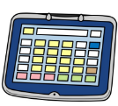

Tricky things
- I don’t like
- It’s difficult for me
- I need you to help me
- I’m still working on

My favourite things
- I like

Things that help me
- It helps me if you


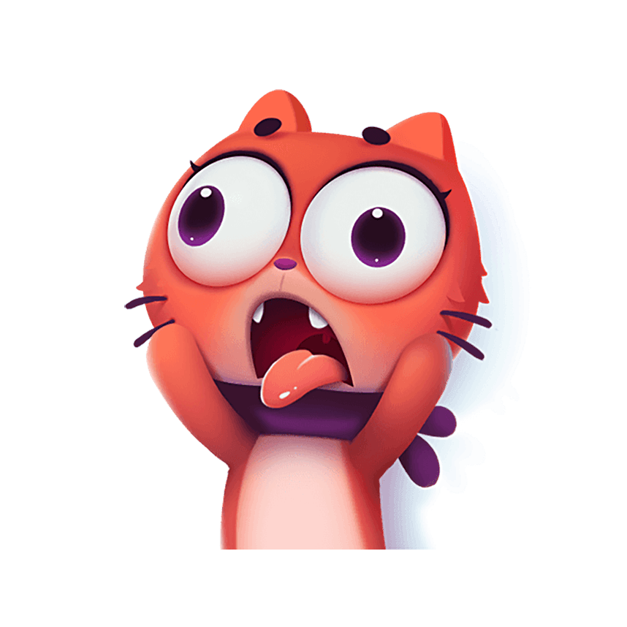

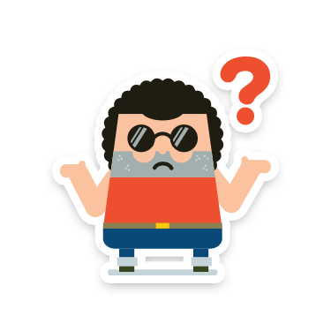
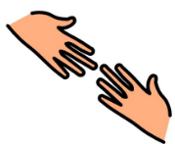
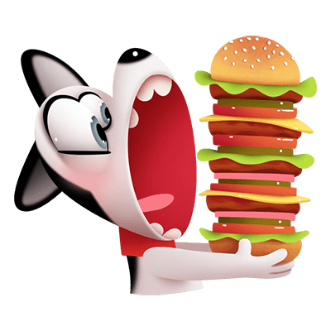
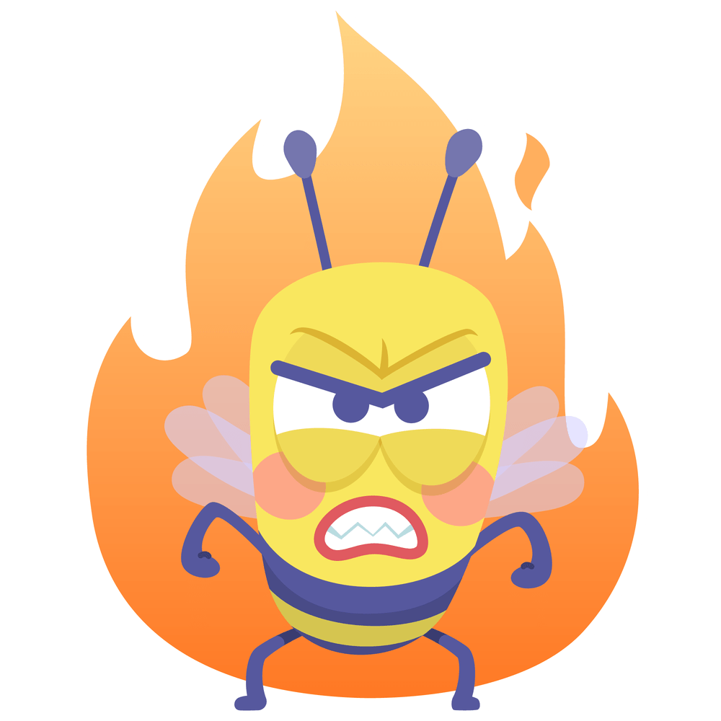



Replace with photo

More things you need to know about me

Important people

If you want to find out more about Passports, look up www.communicationpassports.org.uk


If you want to find out more about Passports, look up www.communicationpassports. org.uk

Hi, I’m
X
- I’m x years old
- I live in x
- I have one big brother
- I have two sisters, X and A
- I have an X cat dog called X
- I go to X school
- I’m in PX

